**Bicycle Events Web Site**

|  |  |  |
| --- | --- | --- |
| Revision | Date | Author |
| 4 | 6/1/2020 | SP |
| 5 | 6/1/2000 | SP |

1. Description

The App is used to organize bicycle events and maintain a community of bicycle enthusiasts.

Users will publicize Bike shows, bike rides and other events.

Users will signup and define their areas of interest (Category).

Show Organizers will register the events.

The site will send emails about the events.

Other users will register to present their wares.

Visitor swill register to attend and after attending will rate them.

1. Users
2. Event Organizers
3. Event Exhibitors
4. Attendees
5. Records
6. User

Used by anyone that access the site.

1. Id
2. Name
3. Email
4. Password
5. Address
6. City
7. State
8. Zip
9. Category: Category ID A combination of drop down and if the category is not found, the user can add one.
10. Accept Email Notification
11. Description
12. Event

Used to describe an event

1. Event_Id
2. Name
3. Category: Category ID
4. Type: (Show, Ride, Other)
5. Organizer: User ID
6. Start Date
7. End Date
8. Address
9. City
10. State
11. Zip
12. Event Description
13. Event Exhibitor

Used by any one that wants to have a booth in a show.

1. Exhibitor: User_ID
2. Event: Event ID
3. Description
4. Event Visitor
5. Visitor: User_ID
6. Event: Event_ID
7. Category
8. Category_ID
9. Name
10. Event Feedback
11. Feedback_ID
12. Event
13. User
14. Comment
15. Rate
16. Screens
17. Main Screen
18. Contents

Before registration or login the dashboard includes all the events regardless of Zip code

Limited by the city of the browser.

1. Main Menu
2. Dashboard : Before a user logs in the program finds the location of the browser. Get the zipcode and displays the events and stores in the zip code.
3. Activities.
4. New User
5. Register
6. After registration the program displays the dashboard based of her zip code.
7. Registered User
8. Login
9. After registration the program displays the dashboard based of his zip code.
10. Menu:
11. Before registration or Log in: Login, Register, about
12. After registration or Log in: Start Event, Participate in Event
13. Dashboard
14. List of events
15. List of bicycle stores in the zip code of the user.
16. New Event button: for organizing an event.
17. Event:
18. Start and end
19. Name
20. Category
21. Description
22. Exhibit button: When clicked gets the event exhibitor registration screen.
23. Visit button: When clicked gets the event visitor registration screen
24. Store: Bike Shop
25. Name
26. Address
27. Description.
28. Link
29. Image
30. Search menu by Subject, City, State and Zip. Accordingly the events and the stores are selected.

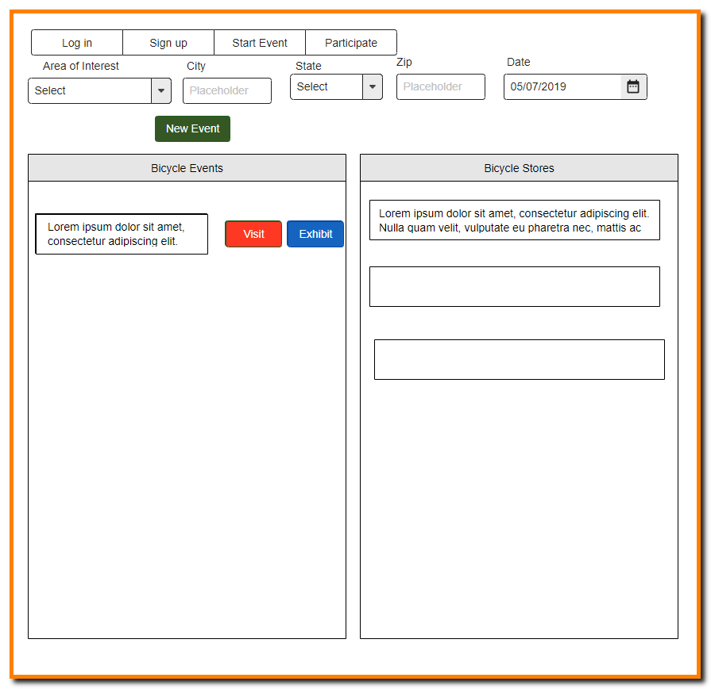

1. User Signup
2. Have all the items of the user record.

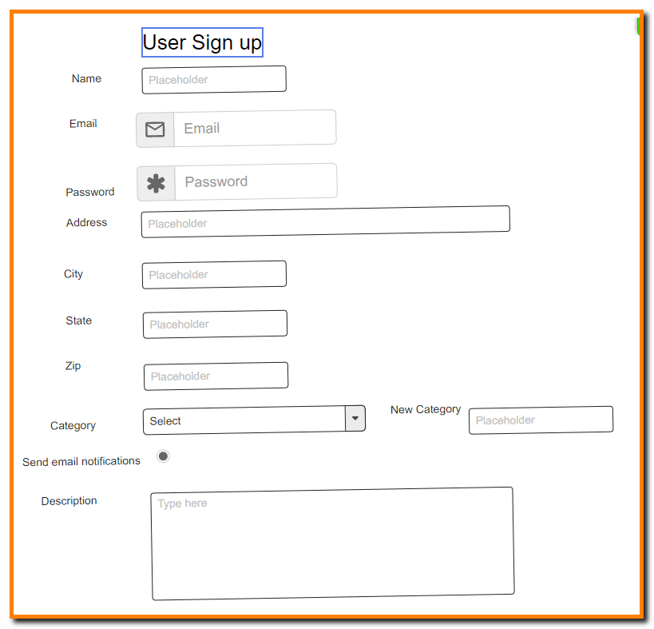

1. New Event
2. Have all the items of the event

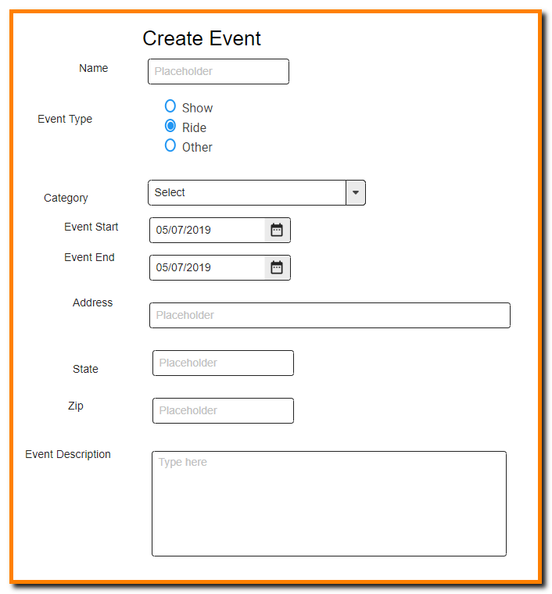

1. Event Exhibitor Registration
2. Have all the items of the Event Screen

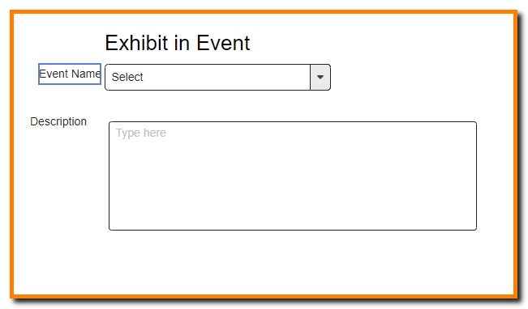

1. Visitor Registration screen

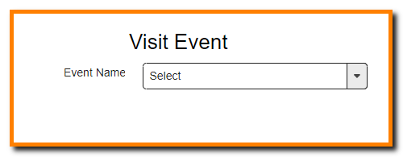

user: [{

    type: Schema.Types.ObjectId,

    ref: "User"

}]

EventSchema

_id,

presenters: [{

    type: Schema.Types.ObjectId,

    ref: "Exhibitor"

}],

Exhibitors: [{

    userRef: {

        type: Schema.Types.ObjectId,

        ref: "User"

    },

    description: String

}]

const currentEvent = new Event.findById(req.body.eventId)

const newExhibitor = {

    userRef: req.user._id,

    description: req.body.description

}

currentEvent.Exhibitors.push(newExhibitor)

currentEvent.save()

const newExhibitor = new Exhibitor({

    user: req.user._id,

    event: req.body.eventId,

    description: req.body.description

}).save()

const currentEvent = new Event.findById(req.body.eventId)

currentEvent.presenters.push(newExhibitor._id)

currentEvent.save()